"Visa Independent Profile"

Mithlesh Kush
Contact # | Alternative contact # | Email Address | Skype | LinkedIn
917-733-9212 | 917-733-9212 | mithlesh.kush@gmail.com | N/A | https://www.linkedin.com/in/mithlesh-kush/
Current Location: |  |  | Manhattan, NY
Willing to relocate? If so, please provide the preferred location: |  |  | Not needed, he will commute to client
Willing to attend in-person interview? |  |  | Yes
INTERVIEW AVAILABILITY
(Dates listed must be 48 hours after candidate submission)
Time Slot 1 (Date/Time) |  |  | Time Slot 2 (Date/Time) | Time Slot 3 (Date/Time)
11-17-25 / 10am-12noon EST |  |  | 11-17-25 / 2pm-5pm EST | 11-18-25 / 10am-12noon CST
Time Slot 4 (Date/Time) |  |  | Time Slot 5 (Date/Time)
11-18-25 / 2pm-5pm CST |  |  | 11-19-25 / 10am-12noon CST
Availability to Start |  |  | 12-01-25
Notice Period/ LWD on last project |  |  | 2 weeks
Interviews/ Offers in Pipeline |  |  | No
LIST ALL EMPLOYMENT FOR THE PAST 7 YEARS
Dates of Employment  (Month/Year – Month/Year) |  |  | Parent Employer Name /Project Company Name  i.e. ABC Staffing / Project at XYZ Client Name | Location
Jan 2024 – Present |  |  | GFT / Royal Bank of Scotland | Stamford, CT
Feb 2022 – Sept 2023 |  |  | Genesis / Bank of America | NYC,NY
Sept 2020 – Jan 2022 |  |  | Tek System/USAA | San Antonio,TX
Feb 2019 – July 2019 |  |  | Insight Global / Paypal | NYC,NY
SUPPLIER SYNOPSIS
Mandatory Skills  (As listed in JD) |  |  | # of Years’ Experience | Candidate’s relevant hands-on experience
Program Management |  |  | 10+ Years | Set up the complete PMO office for Standards & Poors.
Data Mapping |  |  | 20+ Years | Done data mapping in most of the projects and involved in data mapping in last 2 projects as well with RBS and BOA
Transaction Monitoring & KYC |  |  | 5+ | Worked on it with Paypal, USAA
Nice to Have  (As listed in JD) |  |  | # of Years’ Experience | Candidate’s relevant hands-on experience
ETL Testing and DB |  |  | 3+ Years | Done ETL testing and DB few years back with credit Susse.
Knowledge of Web Application server |  |  | No experience | He has no exposure to Web application server
Additional comments: |  |  | Mithlesh is PMP certified project and program manager. He has extensive experience in banking and financial domain. He is into compliance regulations, structing and restructuring processes, entire SDLC, financial management, program management , setting budgets. He also has KYC, AML experience with clients like Paypal, BOA and Credit Susse. He is local to Iselin, NJ , available for interview with 24 hours notice and can start in 2 weeks after the offer.

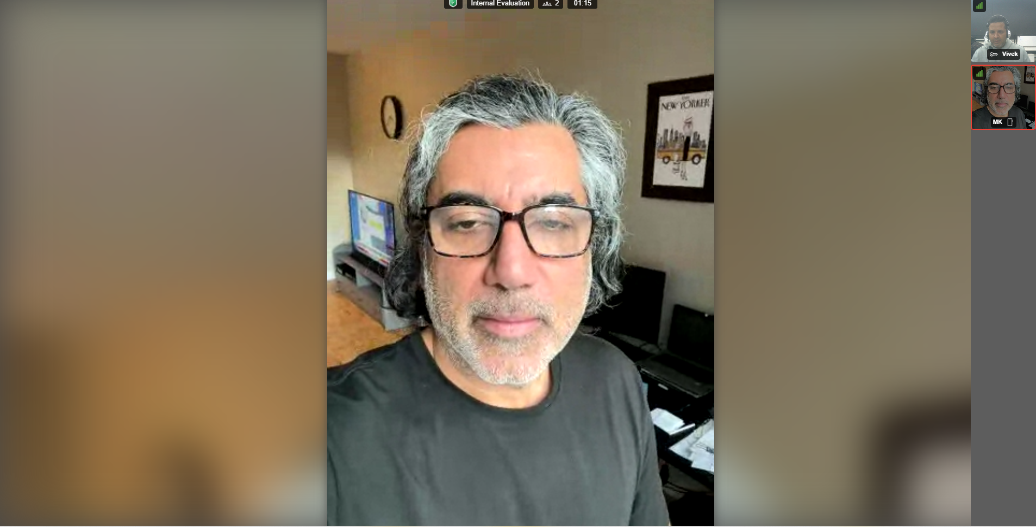

Professional Summary
- Strategic and results-driven Program & Project Manager with over 20 years of experience leading enterprise IT, regulatory, and transformation initiatives across global financial institutions — Standard s Poor’s, JPMorgan Chase, Citi, Bank of America, NatWest Markets, USAA, and Credit Suisse.
- Proven success in PMO establishment, enterprise transformation, regulatory compliance, portfolio mgmt and governance. Adept at aligning global technology programs with business goals, optimizing delivery frameworks, and leading cross- functional teams to deliver multimillion-dollar programs C initiatives on time and within budget.
- Core Technical Strengths:
PMO Governance | SDLC | Agile C SAFe | Regulatory | Compliance | Risk Management | C-Suite Reporting | Agile | Waterfall | JIRA | Confluence | Planview | ServiceNow | Rally | MS Project | SharePoint | Version One | MS Suite

Soft Skills
- Stakeholder Management: Aligned 12+ global business units and regulators (FCA, OCC) to secure annual Book of Work approvals at NatWest and Bank of America.
- Executive Communication: Presented SteerCo decks to C-suite and boards, translating technical risks into business impacts; achieved 100% approval rate with peer reviews.
- Team Leadership: Led 10-member analytics team at USAA through enterprise forecasting and expense governance; improved delivery velocity 25%.
- Conflict Resolution: Mediated cross-silo disputes between IT, Legal, and Front Office during MRA consent order remediation; unblocked 6-month stalled initiative.
- Change Management: Drove adoption of new e-trading platform across 3 regions via town halls, training, and feedback loops; achieved 95% user uptake in 60 days.

Career Highlights
- Built and led the Ratings IT PMO for Standard & Poor’s.
- Delivered global banking transformation programs under strict regulatory timelines.
- Designed performance governance frameworks and KPI dashboards for C-suite.
- Managed cross-functional global teams delivering multimillion-dollar initiatives.

Education & Certifications
- Columbia University, New York, NY Dec 1996
Graduate Certificate – Management Information Systems (MIS)
- Rider University, Lawrenceville, NJ May 1993
Bachelor of Science – Biology (Minor in Chemistry)

Certifications
PMP, SAFe Agile

Professional Experience
NatWest Markets (Royal Bank of Scotland), Stamford, CT Jan 2024 – Present
Senior Project Manager
- Lead enterprise EOL (end-of-life) e-trading platform transformation across UK, APAC, and US.
- Oversee book-of-work planning aligned with UK FCA regulatory standards.
- Manage decommissioning/migration of banking systems and modernization of payments and reporting platforms.
- Collaborate with Finance, Legal, and Regulatory teams for compliance and approvals.
- Present Steering Committee documentation to senior stakeholders.
- Supervise an 8-member global delivery team ensuring seamless data center transitions.

Bank of America - Global Technology Group, New York, NY Feb 2022 – Sept 2023
Senior Project Manager
- Delivered Equity Flow Analytics Trading Platform for AMRS, APAC, and EMEA clients.
- Oversaw hardware/software integration and MRA/consent order compliance.
- Served as single point of contact for business units, managing escalations and SteerCo reporting.
- Applied SAFe Agile methodologies for sprints, PI planning, and budgeting.
- Tools: JIRA, Confluence, SharePoint, MS Project, Planview.

USAA- CFO Financial Risk, Regulatory & Compliance Group, San Antonio, TX Sept 2020 – Jan 2022
Senior Project Manager
- Directed first enterprise debit card launch, overseeing production, digital, and testing.
- Managed Consent Order lifecycle and OCC regulatory submissions.
- Led 10-member analytics team managing financial forecasting and KPI optimization. Tools: Salesforce CRM, Rally, RRAIT.

PayPal-Global Tax Reporting Operations Group, New York, NY Feb 2019 – July 2019
Senior Program Manager
- Led FATCA and CRS global client onboarding initiatives, ensuring compliance with
- U.S. and OECD tax transparency regulations.
- Partnered with Deloitte to validate and document FATCA onboarding, reporting, and remediation workflows prior to implementation.
- Directed Consent Order processing, FATCA-CRS remediation, and CP2100 error reporting, aligning all activities with PayPal’s risk and compliance controls across EU, APAC, and LATAM regions.

Bank of America , San Antonio, TX Aug2018-Jan2019
Capital Market Global Technology & Operations Traded Products
Risk and Compliance Group
Program Manager V
- Led trading database and capital markets initiatives, managing end-to-end project plans, resources, and budgets for PMs, BAs, and development teams while ensuring compliance with risk and regulatory standards.
- Directed enterprise-level system and data transformation for traded products, including UAT, production migrations, and remediation of trade data gaps; implemented program dashboards and workflow tracking in JIRA, SharePoint, Confluence, and MS Project.
- Supervised 3 direct-report project managers, coordinated onshore/offshore teams, and utilized QZ Trade/Quartz and Risk Navigator for data analysis, reporting, and risk mitigation.

Nice-Actimize, Hoboken, NJ May 2016 – April 2017
PMO Fraud Detection, Operational Risk, Regulatory & Compliance
Senior Project Manager
- Managed client relations for Fortune 500 financial institutions, serving as senior liaison for KYC, AML, fraud detection, and monitoring.
- Oversaw fraud alerts and automated KYC investigations across ACH, wire transfers, credit card, and check transactions, ensuring regulatory compliance.
- Directed project planning, budgeting, resource allocation, and gap analysis to align system processes with business objectives and KPIs.

Credit Susse-PMO Group-NY City, NY Aug 2015 – Feb 2016
General Counsel & Operational Risk, Regulatory & Compliance
Senior Program Manager
- Led Legal Entity and General Counsel projects, ensuring HQLA client migrations were compliant and aligned with EMEA regulatory standards.
- Managed multi-million-dollar initiatives, including derivative infrastructure, front- to-back testing, and IHC hedge portfolio production releases.
- Built and aligned a PMO group to strategic goals, overseeing budgets, scope, planning, and executive reporting while ensuring compliance with CCAR, Dodd- Frank, BSA, FINRA, FinCEN, and OFAC frameworks.

Citigroup – KYC/AML, Global Compliance s Operational Risk, New York, NY Sept 2013 – October 2014
Senior Project Manager
- Managed AML/KYC projects within the Compliance Portfolio, ensuring full OCC regulatory compliance.
- Implemented MRIA processes for KYC, onboarding, SARs/UARs, and red-flag detection, closing gaps in reporting and business rules.
- Prepared and presented executive-level management reports, optimizing IT operations and automated workflows.

Standard & Poor’s (S&P Global) New York, NY Jan 2007 – Sept 2013
Director
- Established and led the PMO Group, Portfolio Management for Ratings IT.
- Earned ESMA Union accreditation as Director for regulatory compliance.
- Designed executive dashboards and KPIs for senior leadership.
- Directed multi-site global modernization programs.

JPMorgan Chase – PMO Group (CIG) NY City, NY Sept 2002 – Jan 2007
Vice President, Senior Project Manager
- Managed Tollgate Release Processes and oversaw business process reengineering, remapping workflows and implementing best practices.
- Reported on financial status of 20+ Development Platforms, identifying redundancies and potential cost savings for senior management.

